

AQS PlugIn Starter Kit
Installation and Administration Guide

April 22, 2010



11 Princess Road, Unit A
Lawrenceville, New Jersey 08648
Version Control Summary

Version | File Name / Date | Description | Lead/Affiliation
1.0 | March 25, 2008 | Initial Version | Doug Timms
1.1 | July 2, 2009 | Updated to include more details about website management | Doug Timms
1.2 | July 16, 2009 | Add full path for LoggerNet | Doug Timms
2.0 | September 29, 2009  October 2, 2009 (small update) | Update to eNode2008 and include latest features | Doug Timms
2.1 | April 22, 2010 | Release to public | Doug Timms

Table of Contents
1 Document Purpose 3
2 Supporting Document 3
3 AQS Data Flow Installation 4
3.1 (Optional) Install Tribal Environmental Monitoring Website 4
3.2 Enable AQS Administration Screens 4
3.3 Copy in AQS Node Plug-In Files 4
3.4 Database Installation 4
3.5 Node Plug-in Configuration 6
4 How to Make AQS-XML Submissions 7
4.1 Getting Started 7
4.2 Submission of AQS-XML File to EPA 7
4.3 Processing of AQS-XML Submission at EPA 9

Document Purpose

This document serves as a technical reference for the installation, administration and operation of the AQS-XML data flow for submission of AQS data to EPA.

This document includes the following topics:

- AQS data flow installation / configuration (For Node Administrators, Section 2)
- How to use the Node to make AQS Submissions (For Air Program Staff, Section 3)

AQS Data Flow Installation
This section is intended for Node Administrators for the 1 time initial AQS Data Flow installation/configuration. For users who wish to make AQS submissions, please skip to section 3.

Database Installation
In order to support the AQS Data Flow, the following tables are added to the NODE database:

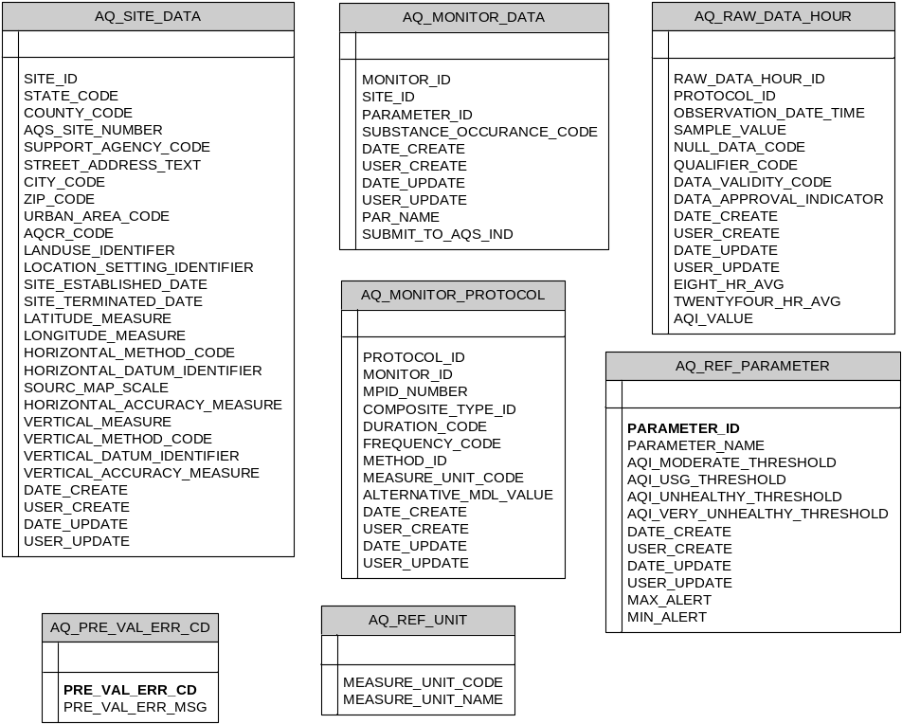
Figure 1: AQS Staging Tables

The purpose for each table is described here:

Table Name | Description
AQ_SITE_DATA | Stored air monitoring sites at the agency.
AQ_MONITOR_DATA | Stores air monitors for each site (i.e. the parameters monitored at each site). Also indicates whether the parameter should be included in AQS submissions to EPA.
AQ_MONITOR_PROTOCOL | Stores monitor protocols for each monitor by identifying the monitoring frequency, method, and unit of collection.
AQ_RAW_DATA_HOUR | Stores hourly air monitoring results. Table can also store 8-hour and 24-hour rolling averages.
AQ_REF_PARAMETER | Reference table listing general parameter information. This table also defines the criteria for AQI calculations.
AQ_PRE_VAL_ERR_CD | Configure the error message text for error messages raised during AQS pre-validation
AQ_REF_UNIT | Reference table listing unit code and unit name

The database scripts are provided in a zip file as part of the installation package, containing the following files:
File Name | Description
1_AQ_tables_create.sql | Creates several new tables in NODE for management of AQS data flow.
2_SP_AQS.sql | Stored Procedure that conducts pre-validation
3_SP_AQS_XML_GEN.sql | Stored procedure that is used to generate the AQS XML file.
4_SP_AQS_XML_GEN_DEL.sql | Stored procedure that is used to generate the AQS XML file in cases when the user selected a previous submission to delete.
5_patch_YYYYMMDD.sql | Run any additional patch scripts included in the installation package.
(Data Migration or Data Insert scripts) | (Optional) Series of SQL files used to populate AQS staging tables

To install the database scripts the following steps should be followed:
- Login to SQL Server Management Studio and run scripts in order listed above.

Node Plug-in Configuration
To configure the AQS Node Plug-In the following steps should be followed:
- Log in to the Node Administration application
- Create AQS Domain:
  - Click on the “New Domain” button in the “Node Domains” web part
  - Enter in Domain name = AQS; Status = Running
  - Allowed Web Services = Solicit, Submit, Query
  - Specify Domain Administrators: these are the users who will be able to access the AQS screens when logging into the Node Administration application
  - Domain Status Message and Domain Description can be left blank
- Modify the AQS_DataFlowWizard.xml file to make the following changes:
  - Change the database connection string to point to your AQS database
  - Change the email address to your own email
- Click on “Go to Operations” for the AQS Domain you just created
- Click “Upload XML File” and then click Save
- Go to Operation Manager configuration page:
  - Add Operation
  - GetAQSDataByDate
  - Click “Generate”
  - Enable Submit
  - Enable GetStatus
  - Supply endpoints:
    - Node 2.0 Test - https://testcdxnode64.epacdxnode.net/cdx-enws20/services/NetworkNode2?wsdl
    - Node 2.0 Production - https://cdxnode.epa.gov/cdx-enws20/services/NetworkNode2?wsdl
  - Supply your NAAS username and password used to submit the AQS file
  - Domain name = default
  - Data Flow Name = AQS
  - Flow Operation Name = AQS
  - GetStatus : Completed
  - GetStatus: Failed
  - Click “Save Operation”

How to Make AQS-XML Submissions

Getting Started
Before you can make AQS-XML submissions, the following preliminary items will need to be completed:

- Obtain a Node Admin Console Account: Contact the NODE administrator to have them create a NODE Administrator Console account. When they create this account for you, they will give you AQS administration rights to allow you to access the AQS Pre-Validation screens. When they create this account for you, you will receive an email with username and password.
- Obtain an EPA CDX NAAS Account: Contact the NODE administrator to have them create an EPA NAAS Account for you. When they create this account for you, you will receive an email with username and password.
- Obtain an EPA AQS Account: You can obtain an EPA AQS-web account by following the instructions found here: http://www.epa.gov/ttn/airs/airsaqs/registration.htm
- Link accounts: Contact EPA’s Exchange Network Help Desk to link your EPA CDX NAAS Account (step 2) with your EPA AQS Account (step 3).

Submission of AQS-XML files to EPA includes 3 major steps:

- (Optional) Bulk data update / correction
- Selection of Pre-Validation Criteria and generation of Pre-Validation Results (Section Error: Reference source not found)
- Submission of AQS-XML file to EPA-CDX (Section 3.2)
- Processing of XML file through EPA’s AQS-Web and review of submission errors (Section 3.3)

Each of these steps is discussed in further detail in the 4 sub-sections below:

Submission of AQS-XML File to EPA

When you are ready to make an AQS submission, go to the Operation Manager page. Select the AQS operation, and then click the Generate button. You will be prompted to enter in a date range for the submission time period. This will generate the AQS XML file.

After you have reviewed the data in the file and are certain that all correct data are included, click the submit button to submit to EPA.

At this point, you could login to EPA’s AQS Web application to complete the submission process (see section 3.3). The remainder of this section 3.2 describes optional steps for tracking the submission status in NODE.

View NODE Submission Logging:
You can monitor the progress of generating and submitting the file within NODE by viewing the “Node Transaction Log” web part on the Node Administration dashboard, as shown here. At this screen, you should see an entry in the data grid with Operation = “AQSSubmission” with a date corresponding to the time you started the submission:

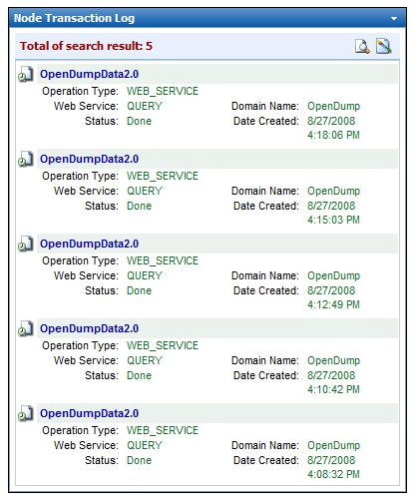
Tip: You can click the Search icon to filter the list of transactions or search for older records.
Click the transaction name to see details of each submission (including error details)
Figure 2: Node Monitoring Screen

Click the Transaction name to view the transaction details:

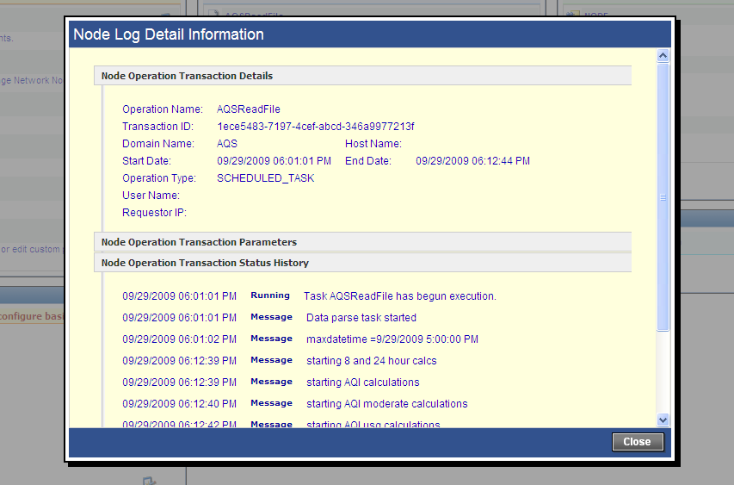
Figure 3: Node Monitoring Details Screen

Here you can view a log of NODE’s processing of the AQS file (reading chronologically from bottom to top).

At this point, the user can log out of NODE. The remaining processing is conducted at EPA’s AQS-Web application, as described in the next section.

Processing of AQS-XML Submission at EPA
Getting data into AQS is a process with 5 steps:

- Transfer your data file to EPA
- Load the data into AQS. If there are no errors, skip to step 4.
- If there are errors:
  - Review and correct the data and return to step 2, or
  - Delete the data and return to step 1
- Run and view reports about the impact of the newly submitted data on the data already in AQS.
- Post the data to the database.

Making a node submission only replaces step #1. The rest of the steps must be done from within the AQS application by a registered user. In the future steps 2, 4, and 5 will happen automatically with a node submission. If the submitted file contains errors, step 3 will always be a manual process.

Testing Process:
- Open the AQS application at: https://iasint.rtpnc.epa.gov/forms/frmservlet?config=aqs&form=A000.fmx
- Log on with your AQS user ID, AQS password, and a database of “AQSQA” (or AQSPROD if submitting to EPA’s production environment). If you don’t remember your password or it has expired, call the AQS helpdesk at 866-411-4372.
- On the welcome screen, select “Screening Group Access”.
- From the pop-up window, select the screening group that ‘owns’ the data that was submitted
- On the top menu, select “Batch”. You should see a screen like the one below:

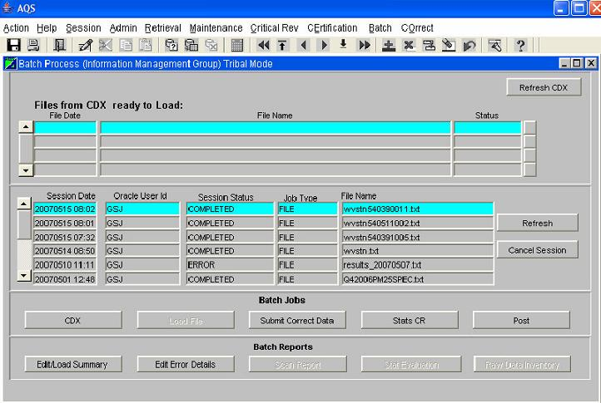

- If the file you transferred via the node does not appear on the upper list, periodically press the “Refresh CDX” button until it does (large files can take 5-10 minutes to arrive from CDX).
- Highlight the file on the upper list by clicking the name (so the line is light blue – it should default to this condition).
- Click the “Load File” button at bottom of the screen. The file will be moved from the upper list to the top of the lower list with a Session Status of ACTIVE. You can click on the “Refresh” button on the right to update the Session Status. It will change to ERROR or COMPLETED.
- If you get a status of COMPLETED, the file had no errors (XML or data quality) congratulations!
- If you get status of ERROR, wait for the job log email to be sent to the email address of record for the user
  - If you get an email that lists no specific data records in error, this means that AQS was not able to successfully open and read your file, and there was probably an XML formatting error.
  - If you do get a count or list of data records in error, this probably means that the XML was read correctly and there were data quality issues, which are explained. (Note the email will only list the first 50 or so errors). This may also mean that required XML elements were missing or superfluous ones were included or a format allowed by the schema is not allowed by AQS (since shared elements are re-used, sometimes AQS actually has a stricter limit on a format than the schema). Be aware that the error list will refer to data elements by the target system record and field names as listed in columns G and H of the DET spreadsheet and not by the XML tag names.

